|  |  |
| --- | --- |
| **Network Infrastructure**  Diploma in CSF / IT  Year 2 (April 2022) Semester 3 | Week 02 |
| Practical |
| Using Packet Tracer to Build and Test a Switch Network | |

**Objectives**

At the end of this practical, student should be able to:

1. use a network simulation tool to build and test a switch network;
2. use the simulation mode.

**Introduction**

Packet Tracer is a stand-alone, simulation environment for networking novices to design, configure, and troubleshoot networks. Students first create a network topology using a drag-and-drop interface. The devices chosen may then be interconnected and configured via a GUI. Additionally, switches and routers may be configured by a limited simulated version of Cisco IOS.

**Activity 1: Building a simple LAN**

* 1. Search for Packet Tracer on PC and launch it. You will see the following screen:

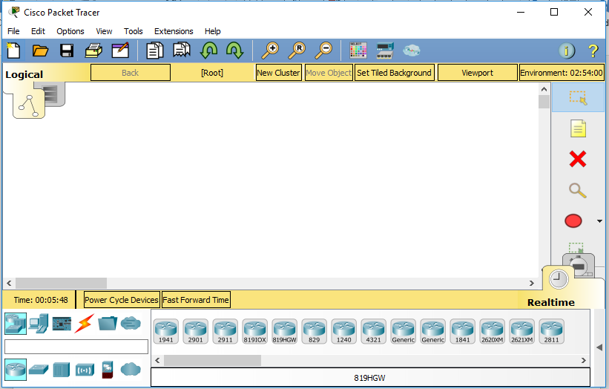

* 1. Next drag a switch to the GUI.

First at the bottom click on **Network Devices:**

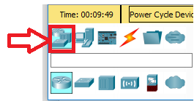

Click on **Switch**:

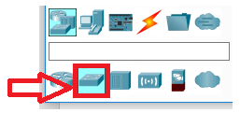

On the right side, drag **Switch 2950T-24** to the GUI.

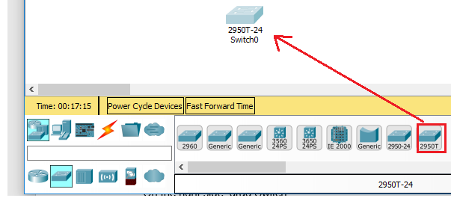

* 1. Next drag and drop PCs to the GUI.

Click on **End Devices** and then drag a PC to the GUI.

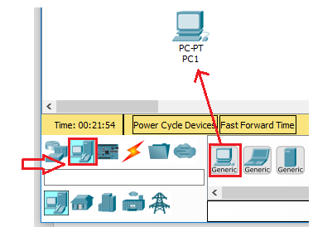

Drag altogether 5 PCs to the GUI.

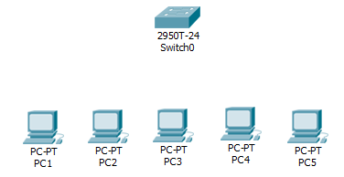

* 1. Next connect the PCs to the switch.

Click on **Connections** and then **Copper Straight-Through** (as shown).

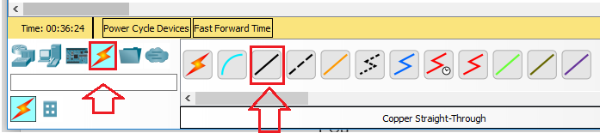

Go to PC1, left click on it and select Fast Ethernet0 (as shown)

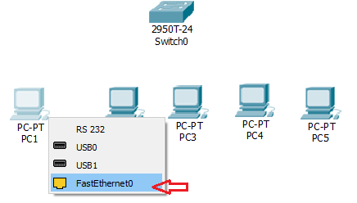

Next to connect to switch, left click on the switch and select FastEthernet0/1.

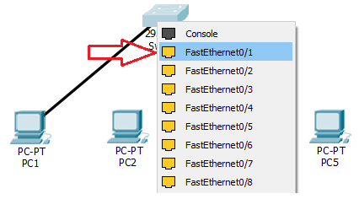

Follow the same steps to connect up all PCs to Switch using Copper-straight cables.

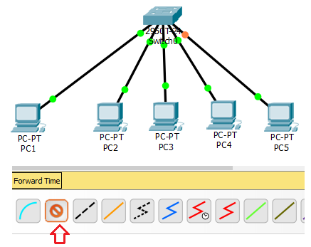

* 1. Next assign IP addresses to the PCs.

Left click on PC1. A form appears and click on Desktop Tab.

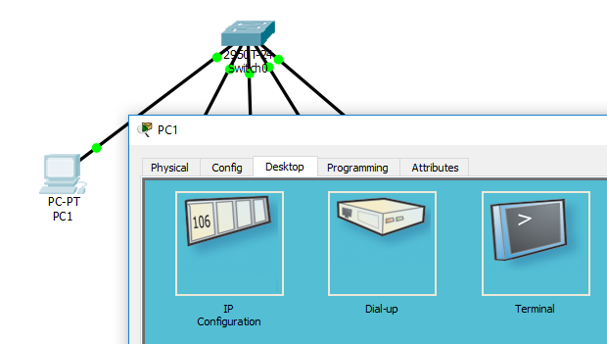

Click on IP Configuration. Set the Static IP address to 153.128.1.1 and subnet mask to 255.255.255.0 (as shown). Close the form.

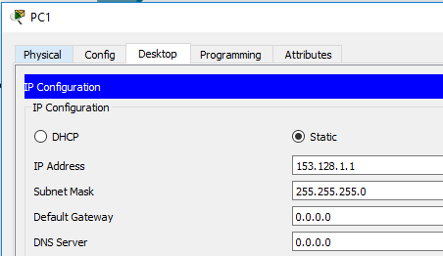

* 1. Follow the same steps to assign the following IP addresses, 153.128.1.2 to 153.128.1.5 to PC2 – PC5 and the subnet mask to 255.255.255.0.
  2. Next do a ping test from PC1 to PC 5. Left click on PC1 and click on **Desktop tab** followed by **command prompt**.

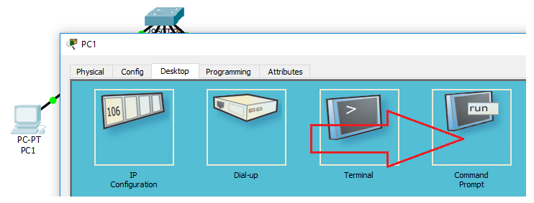

At command prompt, type **ping 153.128.1.5**.

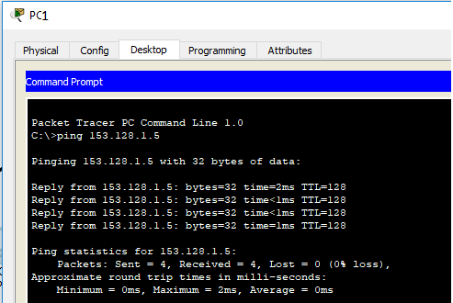

Based on the ping response, is there connectivity between the PCs? ______.

* 1. Save the File by clicking File Menu, Save As. Use “Switch Lab” as filename.

**Packet Simulation**

* 1. Click on **View**, **Simulation Mode**.

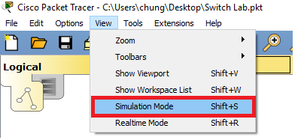

* 1. The simulation panel on the right side appears. Right click on the top of Simulation Panel bar and select **PDU List Window.**

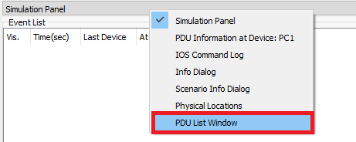

The PDU List Window appears.

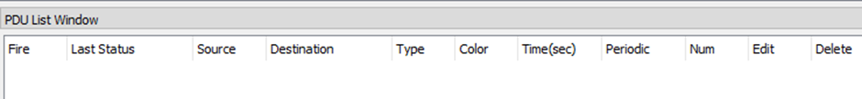

* 1. Click on **Edit Filters** and ensure that only ICMP is checked.

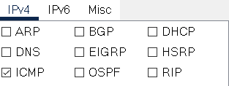

* 1. Add a packet route from, say, PC1 to PC5. Do this by selecting the following icon on the right. Then just click on **PC1** and then on **PC5**.



The following appears on the PDU List Window.

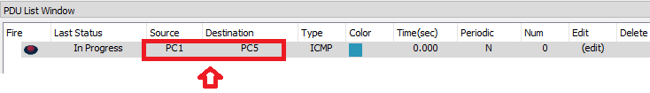

* 1. Run the simulation by clicking the **Play Controls**.

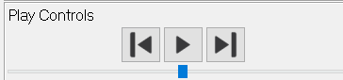

Observe the packet movement.

* 1. Create a new concurrent packet route says from PC2 to PC4 and run the simulation.

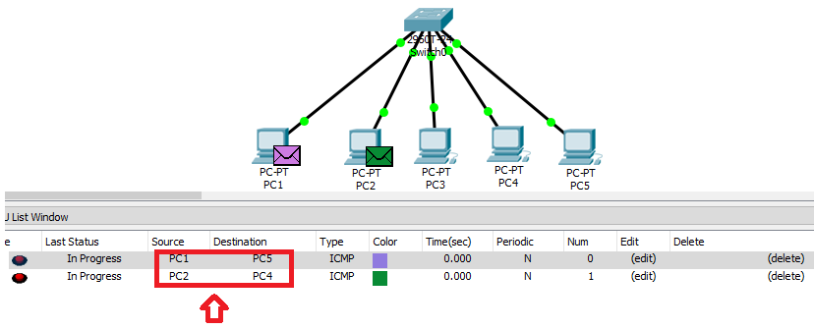

What did you observe? __________________________________________________**.**